Excel 2003 .Net Programmability Issue

**To modify the Office 2003 setup**

1. In the **Maintenance Mode Options** screen of the **Microsoft** **Office 2003 Setup** dialog box, select **Add or Remove Features**, as shown in Figure 2, and click **Next**.

[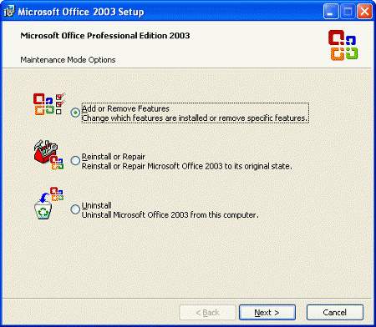](http://msdn.microsoft.com/en-us/library/Aa159923.officeprimaryinteropassembliesfaq_fig2(en-us,office.11).gif)

**Figure 2. Modifying the Office 2003 setup (click picture to see larger image)**

1. Select the **Choose advanced customization of applications** check box and click **Next**.
2. Expand the application-specific node. For example, to get the Microsoft Office Excel 2003 PIA, expand the **Microsoft Office Excel** node and select **.NET Programmability Support**. Click the drop-down arrow next to **.NET Programmability Support** to select update options, and choose **Run from My Computer**, as shown in Figure 3. Do not choose **Installed on First Use**.

[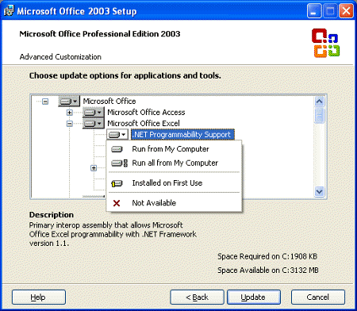](http://msdn.microsoft.com/en-us/library/Aa159923.officeprimaryinteropassembliesfaq_fig3(en-us,office.11).gif)

**Figure 3. Selecting update options for .NET Programmability Support (click picture to see larger image)**

**Note**   Selecting **Run from My Computer** means you want the currently selected feature—for example, **.NET Programmability Support**—to be installed and stored on your hard disk. Selecting **Run all from My Computer** means you want the currently selected feature and all of its subfeatures installed and stored on your hard disk. The **.NET Programmability Support** feature has no subfeatures, so selecting either **Run from My Computer** or **Run all from My Computer** gives the same results. Selecting **Installed on First Use** means you only want the **.NET Programmability Support** feature installed on your hard disk when you use the feature for the first time. In this case, you may need access to the compact disk or network server you used to install Office 2003 in order to install the **.NET Programmability Support** feature.

1. Click **Update**.